# COMPLETE GUIDELINES FOR MICRO-PROJECT

**SUB- SOCIAL AND LIFE SKILLS**

# Guidelines Prepared by Prof Asif Shaikh.

Dear student please follow the following guidelines as described below before you start with Micro-Project

I will discuss all the points with you in the lecture. Also If you face any difficulties, please concern me.

Microproject- page 1.

### COVER PAGE OF MICRO-PROJECT

KALA VIDYA MANDIR INSTITUTE OF TECHNOLOGY POLYTECHNIC Mahada,

Gaikwad Nagar, Malad (w), Mumbai-400095.

### SUBJECT:-SOCIAL AND LIFE SKILLS

Code: - 3112003.

Semester: - CO-2-k, CM-2-K, IF-2-K, EJ-2-K Year: - 2023-24

#### TOPIC: Heath Family Welfare and National Programme

Subtitle: **Provision of safe and clean drinking water**

|  |  |  |
| --- | --- | --- |
| Prepared by the Group Number: **45**  Registration date 15/1/2024.  **Name of the students** | **Roll No** | **Seat No** |
| 1. Ansari Mohammed Kaif | **231260** |  |
| 2. Shaikh Sahifa Mohammed | **231252** |  |
| 3. Shaikh Aisha Muskan | **231242** |  |

**Under the Guidance of Prof. Mohd. Asif Munir Shaikh**.

### ACKNOWLEDGEMENT

We wish to express our profound gratitude to our guide Mr/Ms **Prof. Mohd. Asif** **Munir Shaikh** who guided us Endlessly in the framing and completion of the Microproject.

He/She guided us on the main points in that Microproject.

We are in debted to his/her constant encouragement, cooperation and help. It was his/her enthusiastic support that helped us in the overcoming various obstacles in the Microproject.

We are also thankful to our Principal, Head of the department for extending their support and motivation in completion of the Microproject.

Name of the team Member

### Ansari Mohammed Kaif

* 1. **Shaikh Sahifa Mohammed**

### Shaikh Aisha Muskan

### CERTIFICATE

#### This is certify that the following students of Group:- 45

* 1. **Ansari Mohammed Kaif Roll No 231260 Seat No**
  2. **Shaikh Sahifa Mohammed Roll No 231252 Seat No**
  3. **Shaikh Aisha Muskan Roll No 231242 Seat No**

Of SECOND SEMESTER of Diploma in **Computer Engineering** of Institute KALA VIDYA MANDIR INSTITUTE OF TECHNOLOGY (POLYTECHNIC)

CODE- 0571 has completed the team work satisfactorily in the course

SOCIAL AND LIFE SKILLS (3112003) for the academic year 2023-24 as prescribed in the curriculum.

Place:- Mumbai Date :-

Subject Teacher

#### Prof Mohd Asif Munir Shaikh

**Head of the Department/Principal**

### INDEX

Sr No Index Page no

1. Cover page 1
2. Acknowledgement 2
3. Certificate 3
4. INDEX 4
5. Rationale, values and 5

Aims/Benefits of Micro Project

1. Methodology 6,7,,8,9
2. Literature Review 10
3. Actual Resources used 10
4. Output of the Micro-Project 10
5. Application of Micro Project. 10

# RATIONALE

Micro project for engineering students gives an edge over the race of recruitment to work hard to ensure a good career. The importance of making micro projects cannot be stressed, expert says. In spite of employment practice in recent times students are progressively taking up micro projects to pad up their skill set. By doing a micro project we can gain practical knowledge. In spite of the theory concept, we acquire various industries and also need to know our capacity to complete projects using our specific initiative. So Micro Projects are very important.

### VALUE OF MICRO-PROJECT

Micro projects are helpful that they provide employees a chance to distinguish between student with related background. They also support student to show their talent and they might not have direct effect on the employment. Currently engineering students show an interest in making micro projects as they realize the value of practical training.

### AIM/BENEFITS OF MICRO-PROJECT

Micro project in either to make necessary preparatory action for development and investment project or to Undertaker survey of prefeasibility studies to justify activities within larger project's

### COURSE OUTCOMES ACHIEVE

We understand the community in which they work understand themselves in relation to their community, identify the needs and problems of the community and involve them in problem solving, develop among themselves a sense of social and civic responsibility.

Generate ideas or ways to offer social service or assistance to those in need. This is the outcomes of our microproject.

### 10. METHODOLOGY

1. **Introduction**

Social work with children is one of the core areas of social work intervention. There is varied scope of social work with children across different settings. To be able to work effectively with children or on issues concerning children, certain core skills are required. The Module outlines the range of work that can be undertaken across different settings and basic skills of working with children.

# Scope of Social Work Intervention

# Any kind of social work with children needs to adhere to the overarching framework of the constitutional provisions in India, the national laws, policies, programmes, and schemes that address different issues concerning children. If we find that there are certain gaps in any of the above or that implementation is not happening to the desired extent we can create advocacy and/or campaigns around the same to ensure that the required changes are made. The overall vision of social work with children would be to ensure child rights and child protection for each and every child in society. Child rights is based on the core principles of non-discrimination, right to survival, right to participation, and best interest of the child. As per the Juvenile Justice (Care and Protection of children) Act, 2015, “best interest of child” means the “basis for any decision taken regarding the child, to ensure fulfilment of his basic rights and needs, identity, social well-being and physical, emotional and intellectual development” Child protection is about addressing child rights violation or preventing children from experiencing situations of violence, exploitation, abuse, and neglect. Fulfilment of child rights is a critical responsibility of adults in society who are the duty bearers. The family, community, and State are mandated to work towards child rights. Social work with children can be undertaken at different levels and for different purposes. Intervention can be designed for developmental, preventive, and therapeutic purposes. Given below are further details: (Figure 1.) 4.1 Direct Work with Children: Since the number of children requiring care and protection is large, there is immense scope to engage in direct work with children. Many of us are inclined towards direct work with children; either through work with individual children or through groups. Direct work with children and youth is possible with very young children, school going children, adolescents as well as youth who are nearing adulthood (the word children refers to all young persons who have not completed eighteen years of age).

### Range and scope of social welfare for children

Direct work with children can be undertaken in different ways and across different settings; for example, one can work with children in schools, communities, in residential care Institutions, shelter homes, contact centres or drop-in centres, hospitals, education projects, vocational training centres, and child guidance clinics. A large number of children without family or family support come within the purview of the juvenile justice system. Within the juvenile justice system one can work with two groups of children; child in need of care and protection and child in conflict with law. We can either directly work with the probation department, liaison with the child welfare committee and the juvenile justice board or as part of an organization or NGO work at different levels within the juvenile justice system. The juvenile justice system has several mandated residential care Institutions (Observation Home, Children’s Home, Special Home, Place of Safety). We can directly work with the children admitted in these Homes in areas such as family tracing, counselling, rehabilitation, health, education, and vocational guidance. We can also work with the families of the children.

# What can we do?:

We first need to assess about the child’s situation, areas of vulnerability, impact on the child and scope for intervention. Assessment is not a one-time or one-way process. It is an ongoing, periodic, and reciprocal process and includes the optimal participation of the child. Through assessment we can gain an understanding of the needs of the child, violation of rights, if any, and plan an intervention accordingly. For example, children who are victims or survivors of disasters and/or violence require psychosocial and trauma care along with other priorities.

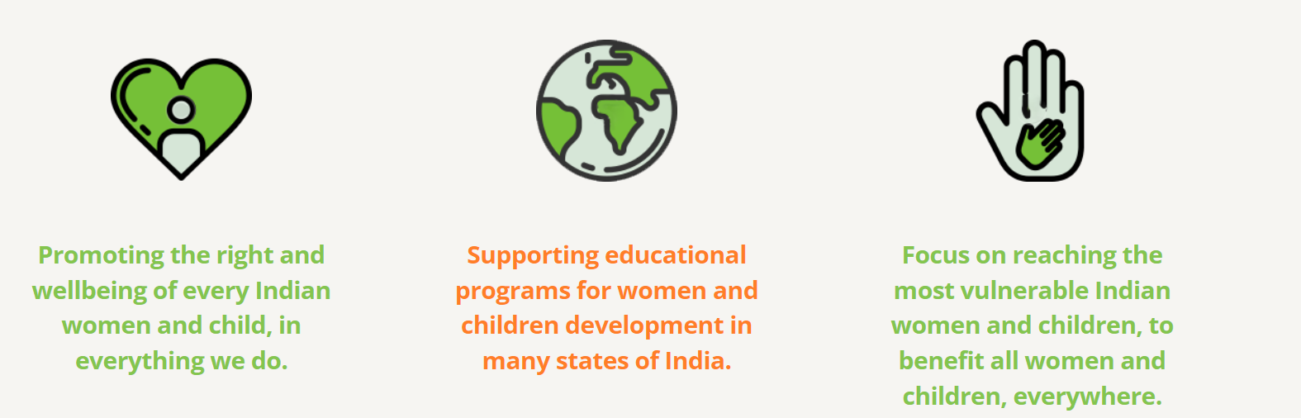

## Working with Family and Other Significant Adults:

A child closely interacts with adults especially during the formative years. They are also dependent upon adults for fulfilment of the basic needs and requirements. Hence working with adults is a very important component of social work with children. At the micro level a child interacts with parents, school teachers, other relations, doctor, neighbourhood, and community persons. At the macro level there are many individuals who indirectly impact the child's life such as the police, government officials, and other stakeholders who influence the policy and legislative framework. Implementation of laws, allocation of adequate budget, access to quality school services, protective mechanism in the community through a vigilant police and community have a direct bearing on child rights and child protection. Therefore, there is a wide scope of work with significant adults at the micro and macro level. The overall aim would be towards creating a culture of ‘child friendly’ approach at all levels of society across all adults. According to the Juvenile Justice (Care and Protection of Children) Act, 2015, “child friendly” means “any behaviour, conduct, practice, process, attitude, environment or treatment that is humane, considerate and in the best interest of the child”.

## Basic Skills for working with Children

Skills is the level of efficiency or competence with which we can do an activity/function and/or responsibility. Skills cannot operate in a vacuum. Social workers working with children build their practice on a range of theories, perspective, approach, knowledge, skills, and research. Social workers working with children build their practice on a range of theories, perspective, approach, knowledge, skills, and research. social work with children, first and foremost we require to develop our own knowledge and perspective on children. It is not sufficient to only understand about situations that directly impact children. We also need to develop critical thinking skills, analyse the larger social realities and context which impact human life including that of children

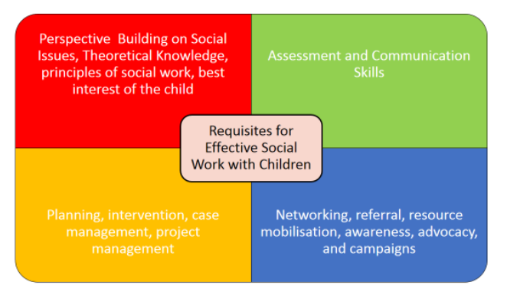

Further, direct Work with children can be in the following areas:

• Adoption

• Foster Care

• Sponsorship

• School social work

• Community-based programmes (education, child labour, child marriage, health, nutrition)

• Outreach work at railway stations

• Hospital

• Child guidance centres or clinics

• Skill building with adolescents or youth

• Direct work with specific groups of children (girl child, children with disability, child in addiction, child

sexual abuse, etc.)

• Institutions or Homes within the juvenile justice system or Homes managed by other registered

organisations as per State rules and procedures

• Specialised work such as trauma counselling

• Rehabilitation work with children rescued from trafficking or children within the juvenile justice system

• Aftercare for children who are completing eighteen years of age but may continue to require support and

guidance

# Perspective building on social work with children:

To be able to be skillful in our work especially in the

area of children we require information or need to build our knowledge around the following:

✓ Social realities, structures, issues, and social problems

✓ Local, state, national, and global socio-economic developments both at the society and Institutional level

✓ Discrimination, deprivation and oppression experienced by groups of people

✓ The policy framework, laws, schemes, and programmer directly or indirectly related to children

✓ Understanding different theoretical perspectives on children

✓ Environmental issues, climate change, and its impact on children

✓ Understanding the impact of conflict, violence, abuse, neglect, and exploitation of children

✓ Conceptual clarity on networking, advocacy, collaboration, coordination, and campaign

✓ Parenting, child rearing, family, and its influence of children

✓ The different categories of vulnerable children, factors of vulnerability and its impact

✓ Rehabilitation and its mechanisms

**LITERATURE REVIEW**

Following data has used from

[www.google.com](http://www.google.com/) [www.youtube.com](http://www.youtube.com/)

[www.openai.com](http://www.openai.com)

<https://tnrd.tn.gov.in/reports/Jain_Report/english/index4_25.pdf>

https://www.infosyspublicservices.com/insights/digitizing-child-welfare-system.pdf

### 11. RESOURCES USED

#### Material Resources

Personal Computer use to make project on it.

We have worked with Partner with existing non-profit organizations focusing on child welfare.We have collaborate with relevant departments for resources and support. We have Mobilize local volunteers to assist in organizing events and workshops.

#### Time Resources

1. project Plan.
2. project schedule.
3. Time for Break down the project into phases, setting achievable milestones.
4. Develop a plan for the project's continuation beyond the initial phase.

### 12. CONCLUSION

There is a wide and varied scope of social work intervention with children. Intervention is possible at micro and macro levels and across different settings. One can work directly with children, significant adults as well as advocating for necessary changes in policy and laws. Social work with children is a specialised area of work. It requires thorough knowledge about children, a rights-based attitude and approach towards children, and being able to plan and contextualise intervention which is relevant and promotes child well-being.

### 14. APPLICATION OF MICROPROJECT

Micro project is a short term fund raising effort to help achieve a specific activity or support a specific individual. Micro projects are great fund-raising tools that help you capture the attention of Donor with a specific actionable goal and urgent giving deadline.

Micro projects are expected to demonstrate activities and deliverables that facilities achieving the output indicator in a main project for example stakeholder consultation, feasibility study, dissemination strategies and business plan for product/service concepts.